**Artificial Intelligence in Enterprise Systems**

**Lab #1 – Git**

**Fulya CALISKAN 100766627**

**Instructions:**

Step 1: Install git in your local machine

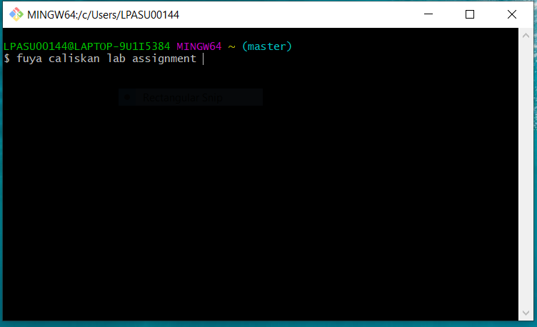

Step 2: Create user accounts in both github and 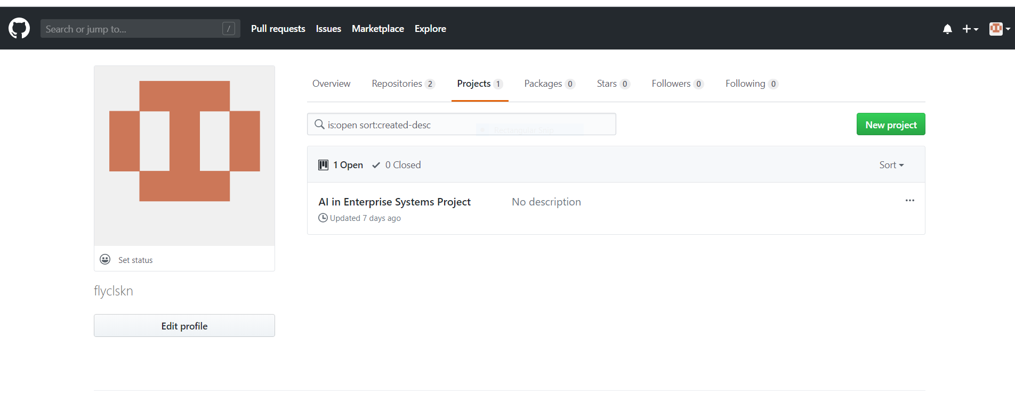gitlab

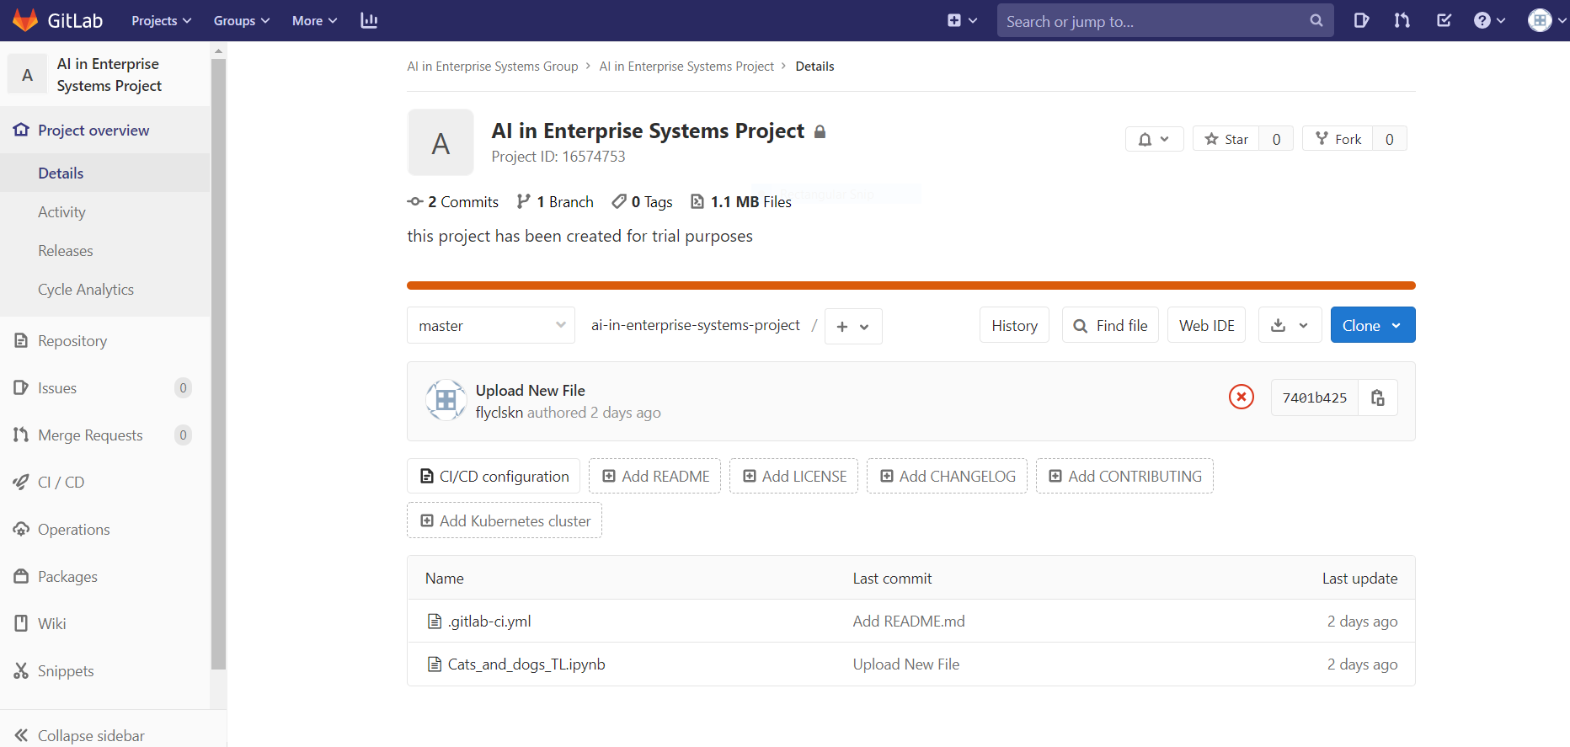

Step 3: Review github and gitlab. Select your remote host (github or gitlab or any new one) and justify your selection.

Both GitLab and GitHub are products providing Git repository hosting service.

GitLab has GitLab CE (open source) and GitLab EE (enterprise), along with GitLab.com. Similarly GitHub has GitHub Enterprise and GitHub.com.

As of now, both github.com and gitlab.com have similar features. Only naming of features may differ a little bit.

The main advantage of GitLab is its opensource nature, which allows you to run GitLab on your own servers.

GitLab allows unlimited private repositories for free whereas for GitHub, it is not free.

GitLab is newer than GitHub, so naturally it is a little less popular than GitHub.

GitLab has its own CI software , which all removes your reliance on external service like Travis.

Step 4: Write a basic program performing key programming activities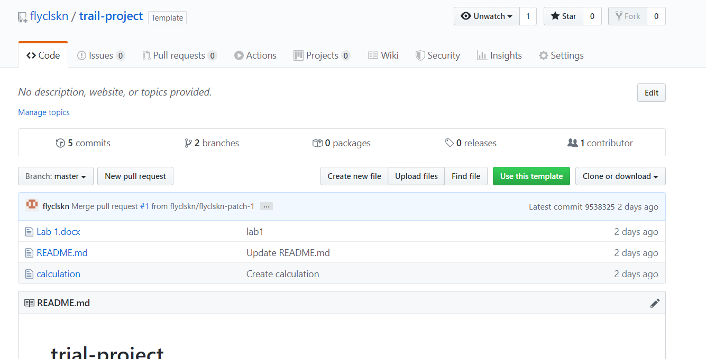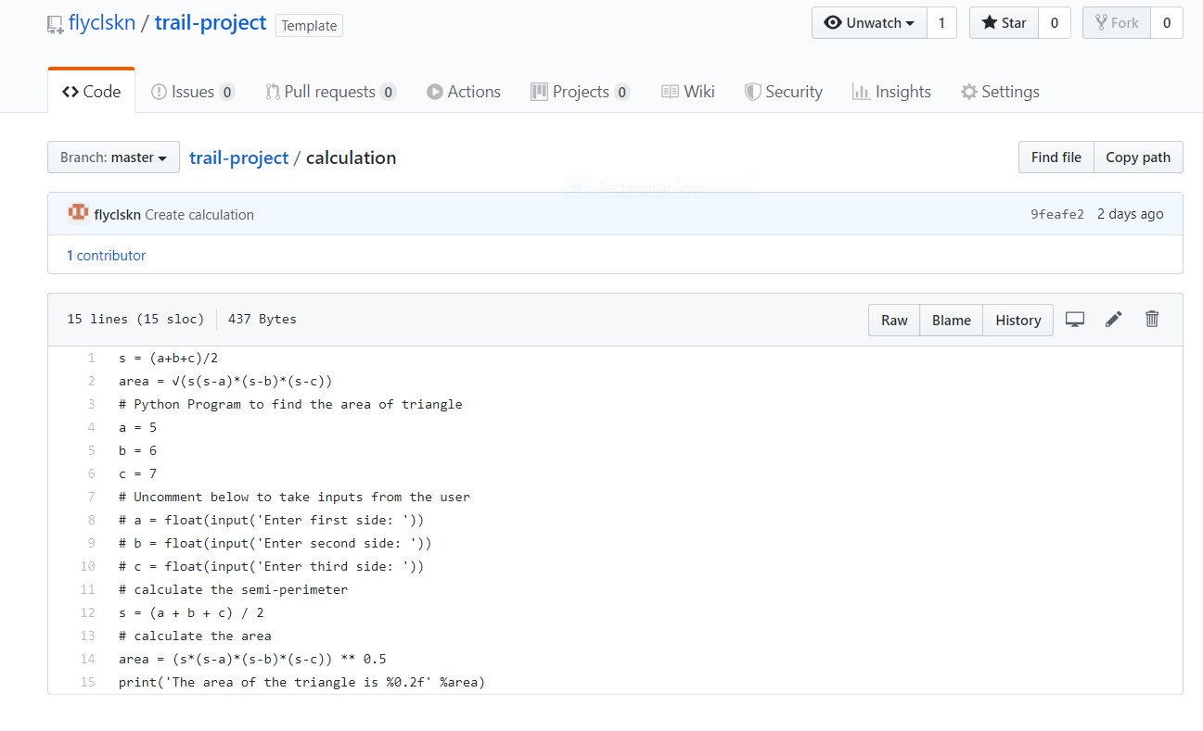

Step 5: Provide screenshot of your command prompt showing success of your commit in the remote host.

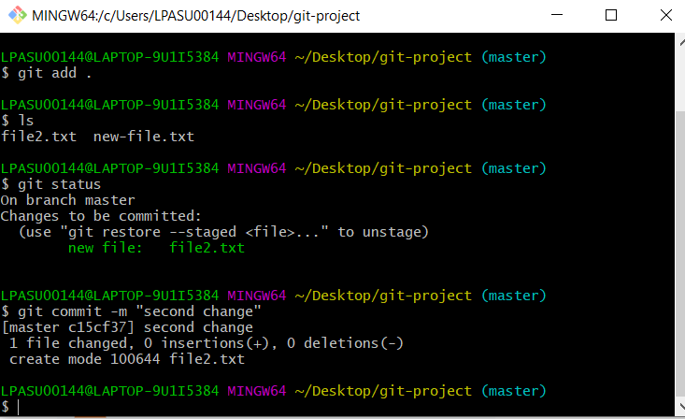

Step 6: Provide a description of your program in the readme.md file

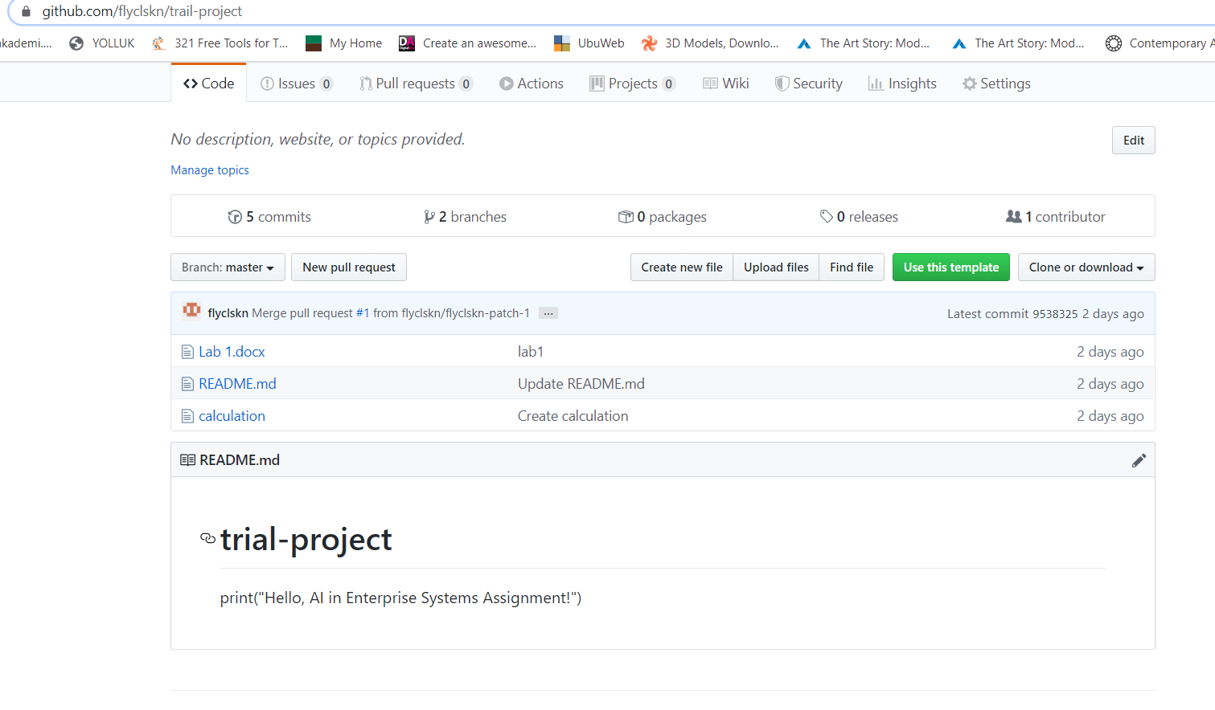

Step 7: Create a branch in your repo and upload any python script in that branch

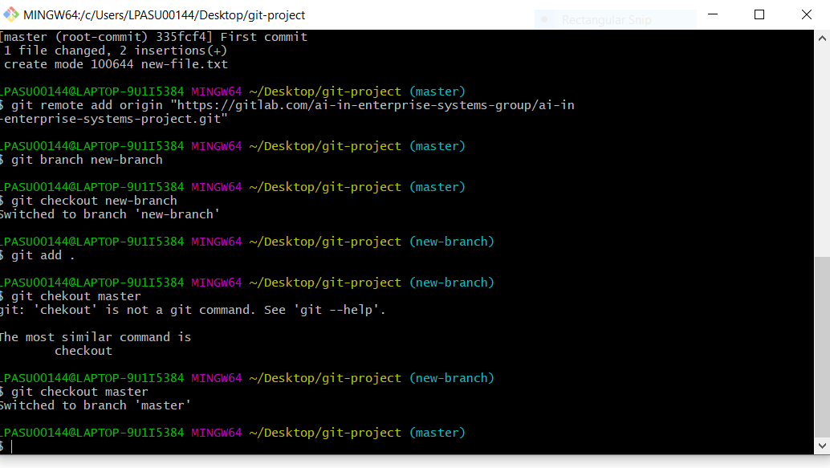

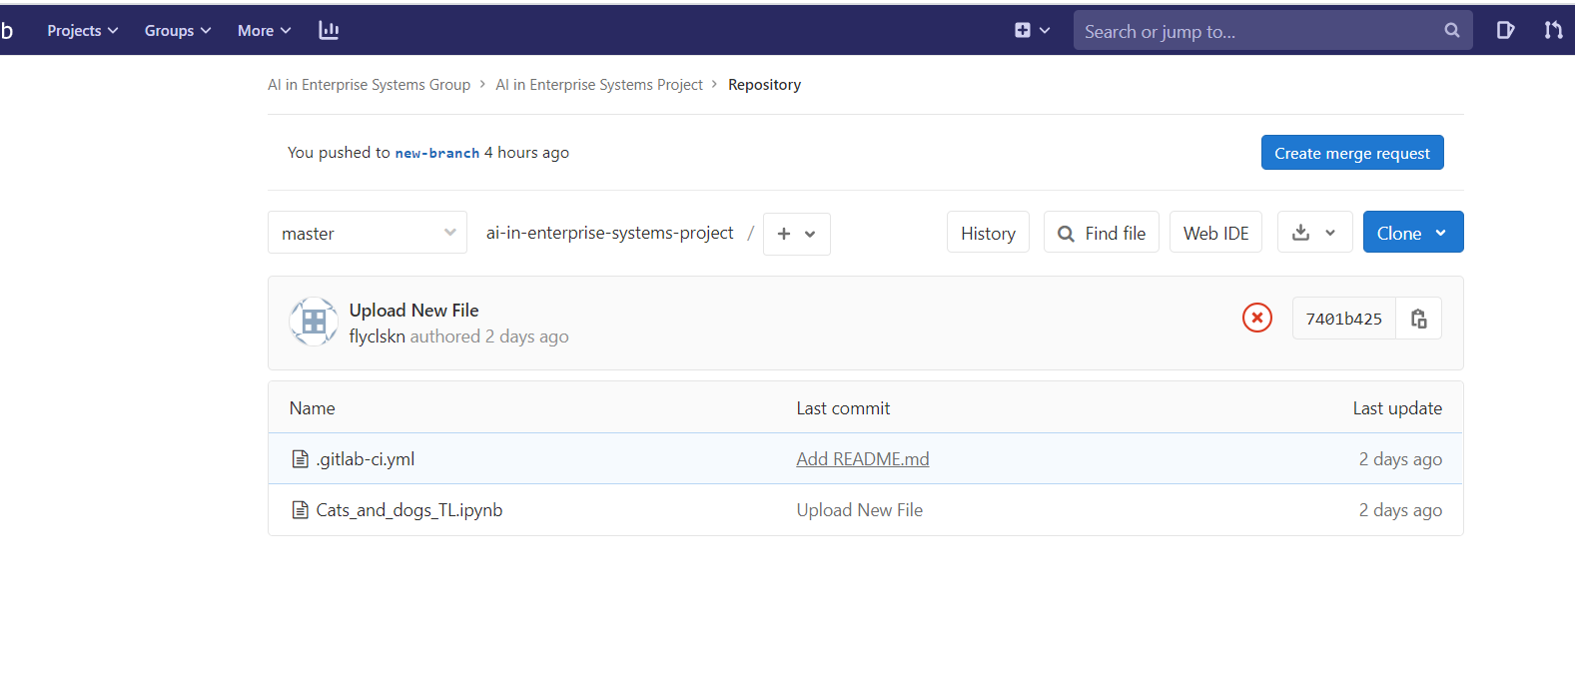

Step 8: Navigate to your newly created branch and provide screenshot showing status of your repo

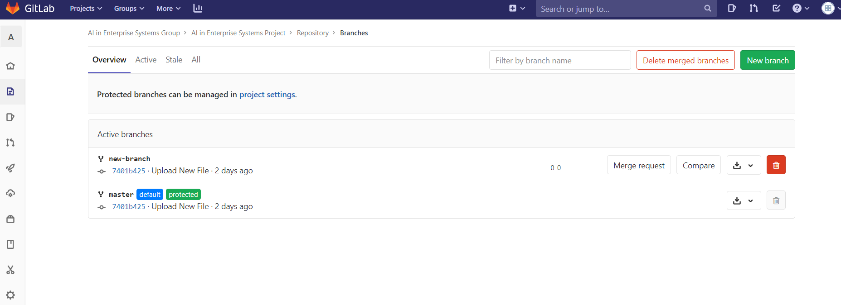

Step 9: Provide a screenshot showing your log of activities and perform your final commit

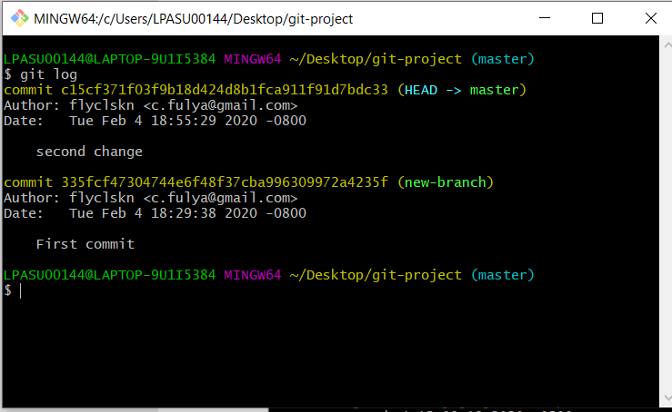

Step 10: Make your repo public and share the link of your repo for check.

Accounts : <https://gitlab.com/flyclskn> <https://github.com/flyclskn>

Raport link: